Roles shape how we interact with each other in the family system. At times, roles function to create and maintain a balance in the family system. These roles have positive and negative aspects to them. The key ingredient is understanding how well these roles work for the family, and how they help or hurt family members in their effort to establish deep, meaningful, and safe relationships. Following are a number of roles that can exist in a family:
Hero "good child." Also known as the "responsible child." This person is a high achiever, carries the pride of the family, and overcompensates in order to avoid the image and feeling of being inadequate. He/She has the skill of being a leader, being an organizer, being goal oriented, and being self-discipline. They often lack spontaneity, the ability to play, follow, and relax, and usually needs to be right.


Rescuer takes care of others' needs and emotions and problem-solves for others in the system; he/she might have difficulty with conflict. He/She takes on the role of rescuer in the name of helping others, though the true meaning is to take care of his/her own needs, such as relieving anxiety. He/She is a Mediator, yet doesn't realize that helping hurts at times. This person lives with a lot of guilt and is challenged with being able to focus on him/herself. 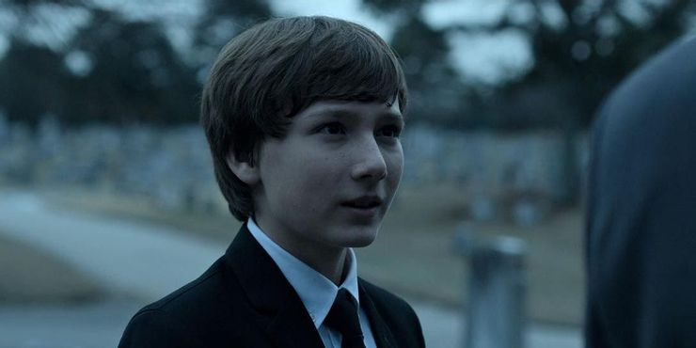 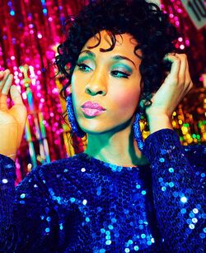

Mediator can be a rescuer type though also works at keeping the peace in the system. This person does the emotional work of the family to avoid conflict. He/She acts as a buffer, and does it in the name of helping others, although it may be for his/hers own needs. This can be a healthy role depending upon how the person mediates. Does he/she trust others to work it out with a little guidance, or does he/she feel he/she needs to direct each step along the way?
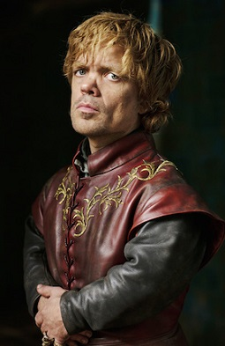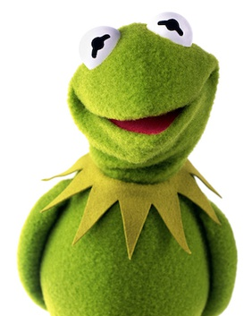

Scapegoat/Black sheep the "identified patient," meaning the person that other family members feel needs the most help. Usually this is the family member who is in treatment. This person carries the family system's symptoms the obvious person with the problems because the family system is not willing to work through its problems or doesn't have the skills to work through problems. The strengths of this person are: the willingness to be close to his/her own feelings, a greater level of honesty, and at times a sense of humor. However, there may also be an inappropriate expression of feelings, and the person may experience social and emotional problems. At times he/she is unable to follow direction.
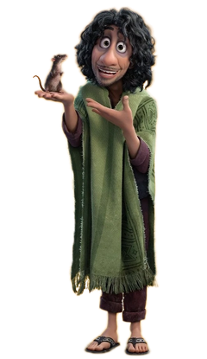

Switchboard this role tends to be the central information person in the family system. He/She keeps track of what's going on in the system by being aware of who's doing what and when. This person has strength in being the central person to go to and understands how the family system is doing. However, his/her focus is everyone else's business, and he/she focuses on others' issues rather than his/her own.
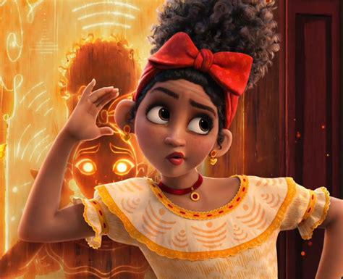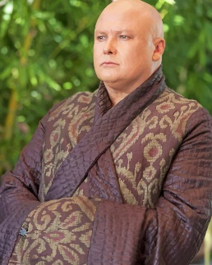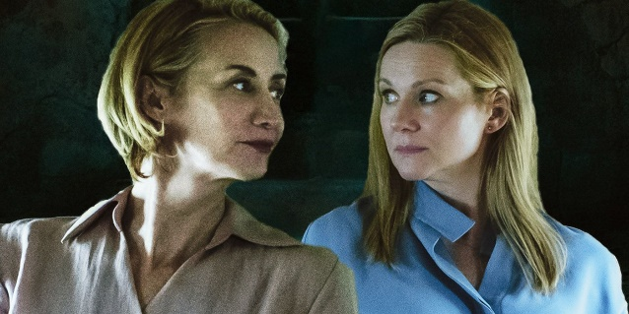

Power broker this person works at maintaining a hierarchy in the family with him/herself at the top of the structure. His/Her safety and security with life depends upon feeling in control of the environment around him/her so they can feel a pseudo (false)safety within him/herself.
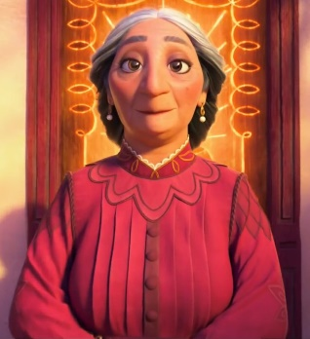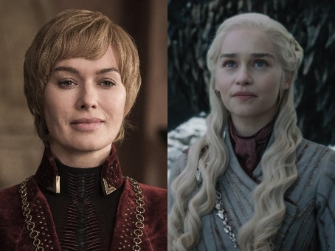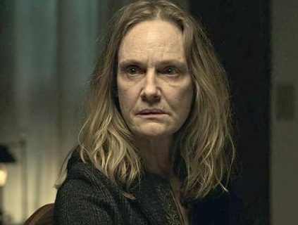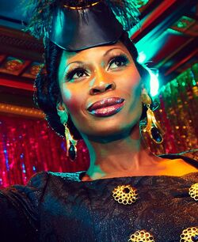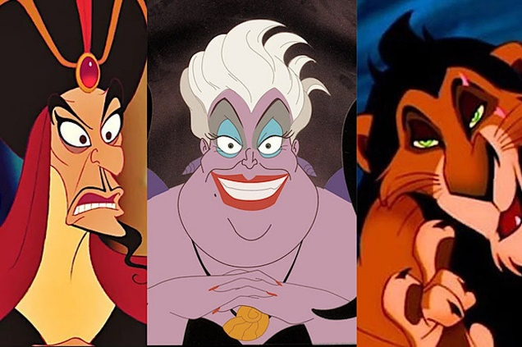

Lost child this is the subservient good child, obedient, passive and hidden in the trauma. The payoff is that he/she avoids being a problem. He/She does not take the time or energy that other children (i.e., Scapegoat) do. He/She has the ability to be flexible and easy going. However, he/she usually lacks direction, is fearful of making decisions, and follows without questioning.
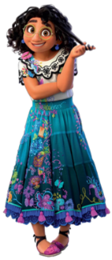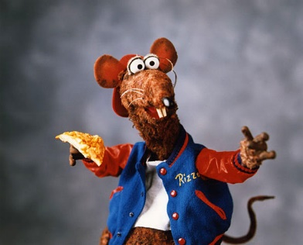
Clown uses humor to offset the conflict of the family and to create a sense that things are okay. This person has a talent to readily lighten the moment yet he/she hides his/her genuine personality.
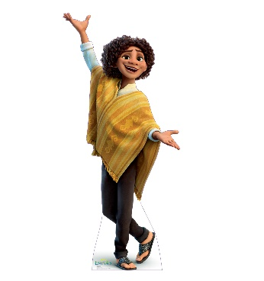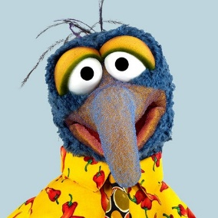

Cheerleader this person provides support and encouragement to others. There is usually a balance in taking care of his/her own needs while providing a positive influence on others around him/her.
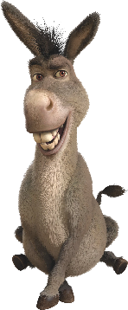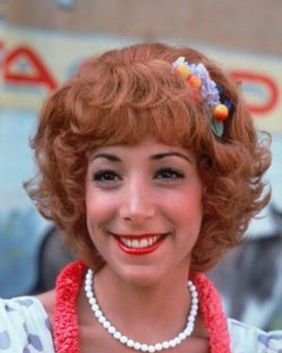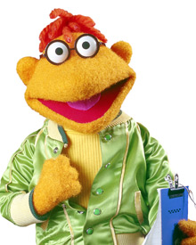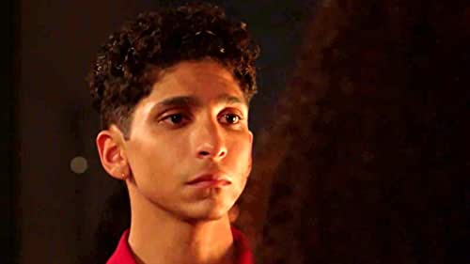

Nurturer this person provides emotional support, creates safety, is available to others, and can be a Mediator. He/She focuses on having and meeting emotional needs, usually in a balanced manner.
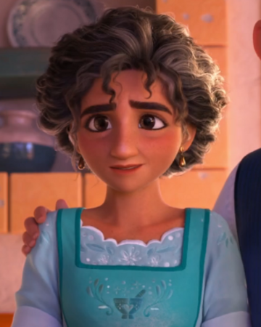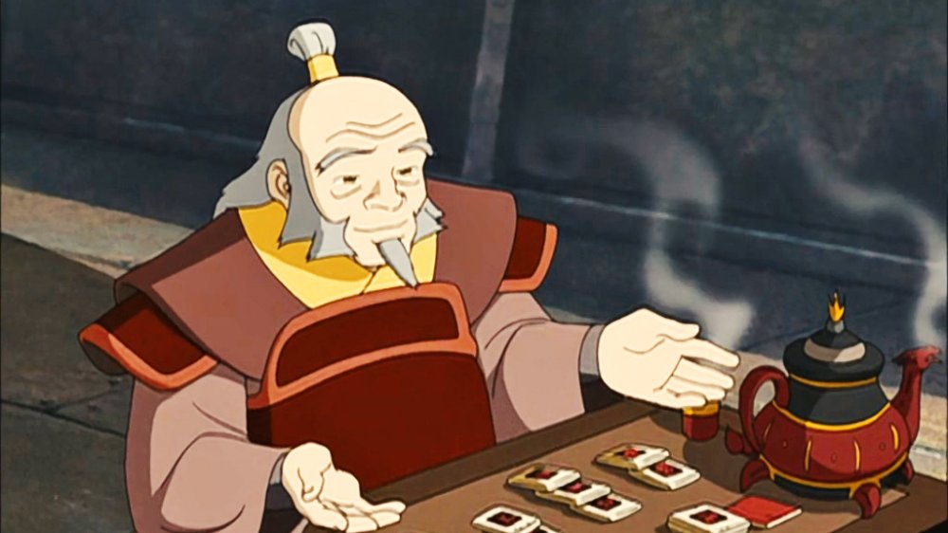

Thinker this person provides the objective, reasoning focus. His/Her strength is being able to see situations in a logical, objective manner. However, his/her ability to connect emotionally with others can be a challenge.
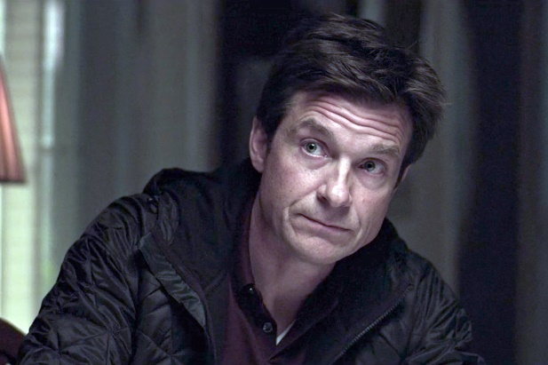

Truthteller this person reflects the system as it is. At times the challenge is how that information is relayed. Other members of this system may be offended and/or avoid this truthteller person because of the power of the truth that he/she holds. Strength occurs when this person is coupled with another positive role player such as a nurturer, cheerleader, etc.
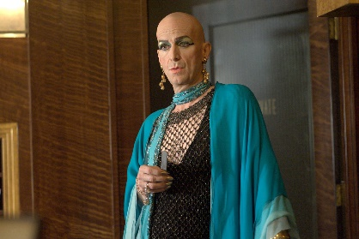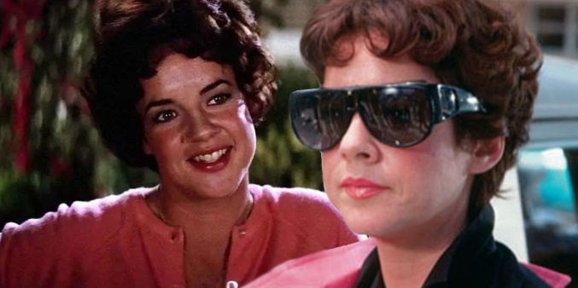

Characters from popular movies and television shows were provided in order to provide examples of each role. You might notice that some of these characters may fit more than one role. This is also true in real life family dynamics. As you reflect on these roles and how your family members do and do not fit them, also remember that it is possible for family members to step into different roles at different times. With that said, most people within dysfunctional family systems have a tendency to step in to one primary and one secondary role.

Questions:
1. If there is a role you feel exists in your family, yet isn’t listed here, how would you describe it or what would you call that role?
2. What is/are your role(s) in your family system?
3. What roles do you see other family members exhibiting?
4. How do you think these roles are working for your family?
5. What roles do you feel don’t work for your family?
6. What are some of the roles you wish your family members evidenced more often?

